Independent Legal Representative Litigation Checklist

Using this checklist:
- Type file name and number, print and attach to all new ILR litigation files
- Complete manually as the file progresses

Purpose of checklist:
Completing this checklist fully and accurately will help:
- Demonstrate that you have met the duties of competence and standard of care expected of an Independent Legal Representative
- Demonstrate that you have met Legal Aid’s expectations of practitioners undertaking legally aided work, articulated in the Quality Standards
- Another solicitor in the event they need to quickly identify the progress you have made with this matter
- If you are audited by Legal Aid

Note:
- This tool is designed as a prompt only. It does not proscribe how litigation should be conducted in Independent Legal Representative matters and is not exhaustive
- This document could potentially be considered a client document and provided to the client upon request (rule 14 Australian Solicitors’ Conduct Rules) or as a result of a GIPA request

Part A: Open File and Start Proceedings

Step One - Open File
Task | Details/Date Done
Appointment by Court
File a Notice of Address for service
Letter to parties enclosing NOA and advising of appointment as ILR
Read documents and start case strategy.
Print completed case strategy and retain on file.
Prepare chronology
Or copy and paste from case strategy.
Consider contacting professionals where appropriate (e.g. school, childcare, counsellor)  Consider the best way to gather evidence (in person, phone, email). | List details of professionals contacted and date of contact.

Step Two- Prepare for Proceedings
Task | Details/Date Done
- Meet with the child as soon as possible after appointment;  Meeting with child(ren) requires consideration to be given to the following:  - The age, cognitive ability and emotional maturity, education, cultural background, possible disability (physical or intellectual) and language proficiency of the child(ren)  - How many professionals the child(ren) has/have already met (avoid systems abuse). | If meeting with the child(ren) see Appendix A
Taking into account the above factors, consider writing to the child using plain English to confirm the lawyer’s advice as to the lawyer-client relationship and as to the pending care proceedings.
Consider issuing subpoenas at the earliest opportunity including:
- Police;
- Department of Communities and Justice;
- Medical Records;
- School Records.
Consider whether appropriate to make an assessment application considering:
- Whether the assessment is likely to provide relevant information that cannot be obtained elsewhere;
- Whether the assessment is likely to cause the child distress and whether this will be outweighed by the value of the information to be obtained;
- Whether there have been previous assessments and these caused distress to the child;
If considered appropriate, draft assessment application, identify the documents to be reviewed by the clinician (including subpoena material), file and circulate to the parties for their comments
If assessment order made, forward two copies of all documents (including
subpoena material) to the Children’s Court Clinic within 7 days of
the making of the Order.
Meet with the child(ren) to explain the assessment process.

Part B: Interim Hearings, Mention/Directions Hearings, Dispute Resolution Conference
Complete for all Court events
Task | Details/Date Done
Explore with the child his or her wishes in relation to all major decisions that are to be made at the Court event;
Record Outcome
Consider issuing additional subpoenas where required
Attend Dispute Resolution Conference and take instructions from client as to how they may wish to participate.

Part C: Preparation for Trial
Task | Details/Date Done
Consider settlement negotiations
Prepare and file documents (e.g. witness affidavits, subpoenas etc)
Prepare and file Case Management Document
Issue updating subpoenas
Ensure witnesses (including any Children’s Court Clinician or other expert) are on notice
Meet with the child and consider appropriateness of the child participating in framing appropriate proposals which can be used in the conduct of the proceedings, ensuring that you avoid involving the child in an adversarial way in the proceedings if possible.
Consider whether to prepare wishes statement or whether wishes of the child are already before the Court (ie through a clinic report)

Step Three- Trial
Task | Details/Date Done
Outcome of trial
Record outcome
Meet with the child to explain any orders made.

Step Four- Finalise File
Task | Details/Date Done
Once discharged, submit a File Outcome to the Grants Division

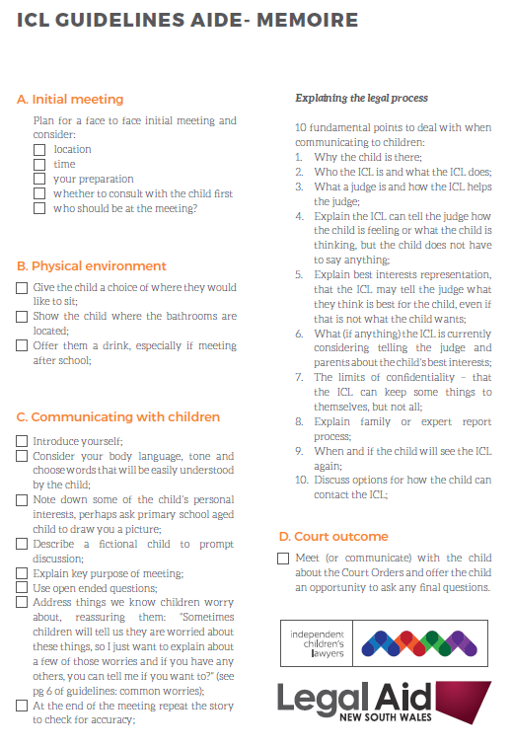
Appendix A

