ICL Litigation Checklist

Using this checklist:
- Type file name and number, print and attach to all new ICL litigation files
- Complete manually as the file progresses

Purpose of checklist:
Completing this checklist fully and accurately will help:
- Demonstrate that you have met the duties of competence and standard of care expected of an ICL
- Demonstrate that you have met Legal Aid’s expectations of practitioners undertaking legally aided work, articulated in the Quality Standards
- Another solicitor in the event they need to quickly identify the progress you have made with this matter
- If you are audited by Legal Aid

Note:
- This tool is designed as a prompt only. It does not proscribe how litigation should be conducted in ICL matters and is not exhaustive.
- ICLs should be familiar with the Best Practice Guide for Meeting with Children and the aide memoire at Appendix A. Both documents are available on the website.
- All references to the “website” are to the National ICL Website, icl.gov.au, a tool for ICLs which includes precedents, guides and other important resources.
- This document could potentially be considered a client document and provided to the client upon request (rule 14 Australian Solicitors’ Conduct Rules) or as a result of a GIPA request

Part A: Open File and Start Proceedings

Step One - Open File
Task | Details/Date Done
Conflict check
File a Notice of Address for service
Letter to parties re appointment as ICL (precedent letter and attachments on website)
Include:
- ICL factsheet
- Questionnaire for parent (available on the national ICL website)
- Fee scale/contribution information sheet
Request copies of all filed documents (attend registry and copy from court file if necessary)
Obtain completed questionnaires from parties – applicant, respondent, other parties
Obtain copies of all court documents – applicant, respondent, other parties
Obtain copy of s11F report or family report if completed
Liaise with any Family Consultant or other expert who has been involved in the matter
Undertake urgent work outlined in orders for appointment of ICL
(eg appoint a person to conduct assessment, request drug screen)
Letter to Department of Communities and Justice re appointment (precedent letter on website)
Send any requests for waiver of contribution to Grants Division for determination

Step Two- Prepare for Proceedings
Task | Details/Date Done
Read documents and start formulating case strategy
Prepare draft chronology
Consider issuing subpoenas (check if leave required/obtain leave)
Department of Communities and Justice liaison - consider whether a subpoena to DCJ necessary
Does a Magellan report already exist or are there records already available?
Consider subpoenas to obtain:
- Police records
- Medical records (consider the relevance of material sought and impact on therapeutic relationships between treating professional and child/parties)
- Other relevant material
Consider whether Family Report or Expert Report is appropriate
Where order for appointment of expert is appropriate:
- Make enquiries with experts re availability and fees
- Obtain approval from the Grants Division for funding of expert if parties or a party legally aided or if exceptional circumstances exist
- Draft Minutes and letter of instruction
- Send to parties, requesting consent
- Send to Associate or Case Co-ordinator if appropriate
- Include leave to provide copy of subpoenaed material to expert
- Ensure funds are held in trust if parties are funding the report privately before expert is briefed
- Send draft letter to expert to parties
- Brief expert
Meet with child(ren) taking into account the age, cognitive ability and emotional maturity of child(ren) and any other circumstances (refer to aide memoire at appendix A)
Prepare and file court documents as required (Case Outline, Minute of Order)
Appear at first return date
Comply with orders made on first return date

Part B: Interim Hearings
Complete for all interim hearings
Task | Details/Date Done
Outcome of hearing
Record outcome
Prepare engrossed orders
Follow up sealed orders
Consider issuing additional subpoenas where required
Meet with child/ren if appropriate to explain outcome

Part C: Preparation for Trial

Step One- Consider Family Dispute Resolution
Task | Details/Date Done
Make appropriate referrals to Legal Aid NSW family dispute resolution conferences in the course of proceedings
If the matter is referred to FDR, co-operate with the Legal Aid NSW FDR Unit
Diarise date of FDRS conference
Prepare for FDRS conference
Meet with child/ren before and after FDRS conference if appropriate (refer to aide memoire at Appendix A)

Step Two- Trial Preparation
Task | Details/Date Done
Inspect subpoena documents
Consider settlement negotiations
Consider appropriateness of meeting with the child/ren before the final hearing
Comply with trial directions including advising the expert/family consultant of the final hearing dates in writing
Ensure funds are in trust if expert is required to give evidence/obtain approval from the Grants Division to pay for expert’s attendance
Ensure witnesses are on notice and prepare documents as directed
(e.g. witness affidavits, subpoenas etc)
File additional affidavits where required and as appropriate (from teachers, counsellors, case workers)
Seek approval of the Grants Division for counsel to be briefed
Brief counsel with adequate experience/ICL training
Promptly reassign the Grants Online invoice for counsel’s fees to counsel, to enable them to claim their fees directly from Legal Aid NSW
File case outline
Promptly provide instructions to counsel in writing, including a complete memorandum and brief
Prepare ICL costs notice

Step Three- Trial
Task | Details/Date Done
Attend trial to appear/instruct counsel
Record outcome
Prepare engrossed orders (where ordered)
Email court engrossed orders (where ordered)
Follow up sealed orders (where required)
Meet with child/ren to explain outcome (refer to aide memoire at Appendix A)
Undertake any post-order work in accordance with orders
Make an application for costs at trial (unless negotiated or waived)

Step Four- Finalise File
Task | Details/Date Done
Ensure all follow up is complete
- Orders provided to relevant people and agencies
e.g. schools
- Meet with child(ren) to explain orders, if required (refer to aide memoire at Appendix A)
- Other
Submit a File Outcome to the Grants Division
Provide copy of any costs order made to Grants Division

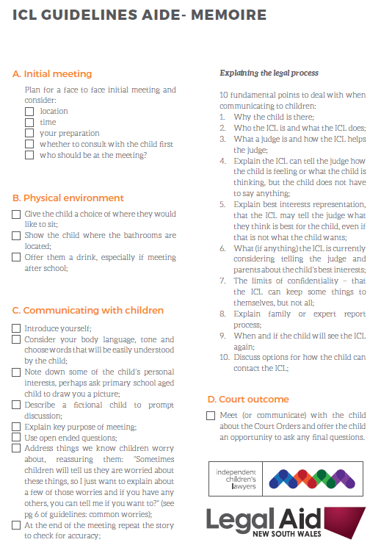
Appendix A

