Children’s Criminal Law Checklist

Use this checklist for:

Duty Work

Defended Hearings

Sentence Matters

District Court Appeals
- Supreme Court Bail

Using this checklist:
- Write child’s full name, Legal Aid File/ID number and CJEP/CAN
- Print and attach to all Children’s Criminal Law files
- Complete the checklist as the matter progresses

Purpose of checklist:
Completing this checklist fully and accurately will help:
- Demonstrate that you have met the duties of competence and standard of care expected of a lawyer representing children in criminal law matters in the Children’s Court
- Demonstrate that you have met Legal Aid’s expectations of practitioners undertaking legally aided work, articulated in the Quality Standards
- Another solicitor in the event they need to quickly identify the progress you have made with this matter
- If you are audited by Legal Aid

Note:
- This tool is designed as a prompt only. It does not proscribe how a criminal law matter in the Children’s Court should be conducted and is not exhaustive
- This document could potentially be considered a child document and provided to the child upon request (rule 14 Australian Solicitors’ Conduct Rules) or as a result of a GIPA request

Appendices
- At Appendix A you will find documents that may be of assistance when preparing for a Children’s Court Defended Hearing
- At Appendix B you will find documents that may be of assistance when preparing for a Children’s Court Sentence

Part One - Duty Work

Step One- Attending the Children’s Court
Task | Details/Date Done
On rostered list days the duty solicitor should arrive at 9.00 am or at such other time as requested by Legal Aid NSW
Ascertain whether there are fresh custodies that require your attention. Priority should be given to children in custody

Step Two- Conferencing the Child
Task | Details/Date Done
Obtain all relevant material from the child, and where necessary the prosecutor, including:
- The Police Facts
- Bail conditions
- The child’s criminal history
Explain to the child in appropriate language:
- What a grant of legal aid means;
- The basis of representation;
- The confidential nature of the lawyer/child relationship;
- The allegations and read the police facts sheet;
- The nature of the charge/s and any defences;
- The nature of the proceedings;
- The possible outcomes of the proceedings and the potential effect on the child including victim’s compensation restitution if appropriate;
- His/her appeal rights and processes and advise on prospects; and
- How the matter will proceed in court
Take the child’s instructions
Check the child’s bail conditions and take instructions for any variation application
Advise a child remanded in custody of their rights to a bail review and to lodge a Supreme Court bail application
Complete a legal aid application for each child who requires assistance

Step Three- Court Appearances
Task | Details/Date Done
Duty solicitors must represent children in the following matters:
- Entering a plea
- Mentioning matters
- Replying to a brief and confirming a plea where appropriate
- Bail applications
- Bail variations
- Sentence matters
- Breach matters
- Forensic procedure applications
- Apprehended Violence Orders where the child is listed as the defendant
Represent the child in court in accordance with the child’s instructions

Step Four- After a Duty Appearance
Task | Details/Date Done
Speak to the child as soon as reasonably practicable following the appearance and confirm the child understands the proceedings and the outcome
If applicable, explain appeal rights and processes and advise on prospects
Provide the child with contact details of the lawyer and/or the Youth Hotline if the child requires further information about the proceedings following the court appearance
A duty application must be completed for each child and the following information recorded:
- child’s address and phone number including land line and mobile
- any instructions
- the outcome (including bail conditions and any orders made); and
- the next date that the matter is in court

Step Five- After a Duty Day
Task | Details/Date Done
Compile the child’s documents incorporating:
- The duty application;
- A copy of the Court Attendance Notices;
- A copy of the police facts;
- A copy of the child’s record;
- Notes of the child’s instructions; and
- Any other documents obtained from the child or the prosecutor of the court.
Write to the child confirming the outcome of proceedings, any future court dates, appeal rights and processes and contact details of the lawyer
If a matter is adjourned for the service of a brief, write to the informant advising the address of the service of the brief and the date by which the brief must be served
If approval is given by Legal Aid NSW, maintain continuity in subsequent adjournments and appearances
If a court is not serviced by Legal Aid NSW office and has adjourned a matter and will not be appearing on the next return date, send the child’s documents to the rostered panel lawyer for the next return date no later than two working days prior to the next court appearance
If you are appearing as a duty solicitor at a court that is serviced by Legal Aid NSW, the application form and relevant documents should be returned to the Legal Aid office within three days of the duty appearance

Part Two - Defended Hearings

Step One- Obtain a Grant of Legal Aid
Task | Details/Date Done
Open and retain a file for the child with copies of:
- Court Attendance Notices
- Police Facts
- Bail Conditions
- Criminal history
- The brief
Read the brief
Complete a legal aid application with the child
Make an application for a grant of legal aid on the child’s behalf
Ensure the matter is ready to proceed and that a grant of aid has been formally approved before setting it down for hearing
Advise the child in writing that the matter has been assigned, the terms of the grant of aid and the hearing date

Step Two- Conferencing the Child
Task | Details/Date Done
Meet with the child, and any appropriate support person, at a place convenient for the child and the solicitor
Explain the role of the solicitor, the nature of the proceedings and how the matter will proceed in court
Explain the role of other parties and the court system and general legal principles (e.g the presumption of innocence, the onus of proof, the right to silence)
Explain the charges to the child
Advise the child on the evidence in the brief and whether there is sufficient evidence to prove a prime facie case
Consider whether doli incapax applies
Advise the child of any relevant defences available to the charges faced by the child. If the child wishes to enter a plea of guilty despite a possible defence, obtain signed instructions
Check the child’s bail conditions and take instructions on any bail variations
Consider the child and whether there are any issues of mental illness or developmental disability that need to be investigated – see s 32 and s 33 Mental Health (Forensic Provisions) Act 1990 and the Mental Health (Criminal Procedure) Act 1990

Step Three- Preparation
Task | Details/Date Done
Issue appropriate subpoenas
Check the commencement date of the proceedings. Note that there is a time limit for commencing summary prosecutions (s 179 of the Criminal Procedure Act (CPA))
Thoroughly read the sections of the Crimes Act (CA) or any other Act that the offence is brought against
Be thoroughly familiar with the elements of the offence
Prepare objections and grounds of the objections
Prepare a chronology of important dates. These dates include the dates of the arrest, CAN, ERISP/statements of accused and witnesses
Go on a view if this will assist. In appropriate cases, take photographs
Identify the real issues in the hearing and disregard matters that are not relevant

Step Four- Considerations for Before the Hearing
Task | Details/Date Done
Get signed and dated statements from witnesses
See s 183- s 188 of the CPA as to requirements for police briefs of evidence. Subject to any regulations the copy of the brief of evidence is generally to be served at least 14 days before the hearing
Request particulars if appropriate- s 166 – s 169 of the Evidence Act (EA)
If representations are made, they must be made in accordance with the time limits specified in the current Children’s Court Practice Note
Consider s 33 of the EA in relation to police officers reading statements and ensure the evidence complies with this section
Consider, in relation to co–accused, the advantages and disadvantages of having a joint hearing: see s 29 of the CPA. There is a danger in having separate hearings: R v Suteski (2002) 56 NSWLR 182. Co–accused may be called to give evidence and their ERISP tendered even if they do not wish to give any evidence
In relation to experts and reports see s 177 of the EA. Make sure that all notices have been served and that you have received or provided a reply
Consider potential challenges to the prosecution case as a result of the conduct of the police by reviewing the following parts of the Law Enforcement (Powers and Responsibilities) Act 2002:
- Search without warrant – Part 4
- Search with warrant – Part 5
- Search etc regarding domestic violence offences – Part 6
- Emergency Powers – Public Disorder – Part 6A
- Arrest – Part 8
- Investigations/questioning – Part 9
- Use of In-Car Video Equipment – Part 8A
- Drug Detection Powers – Part 11
S 138 if the EA: discretion to exclude improperly or illegally obtained evidence
Consider admissibility of admissions by the accused: s 81- s 90 and s 139 of the EA and s 281 of the CPA
S 13 of the Children (Criminal Proceedings) Act (CCPA)- Admissibility of certain statements
Consider also the admissibility of any evidence offered by forensic procedures- see Crimes (Forensic Procedures) Act 2000

Step Five- Running the Hearing
Task | Details/Date Done
Represent the child at the hearing
If the child does not appear you should only represent them in limited circumstances, such as where you have sufficient instructions to do so, or where the prosecution may not be able to establish a prima facie case. If you do act in these circumstances, ensure that you have appropriate instructions to run the hearing
Opening address – will often be useful in clarifying relevant issues. See s 159 of CPA
Have examination in chief and cross–examination prepared before starting. Keep questions and language simple
Consider the importance of putting relevant instructions in cross–examination with consideration given to:
- Browne v Dunn (1893) 6 R 67
- Section 46 of the EA
- R v Birks (1990) 19 NSWLR 677
- R v MWJ [2005] HCA 74
Beware of impermissible questions by the prosecution, such as ‘why would the complainant lie?’
Consider the first and second limbs of May v O’Sullivan (1955) 92 CLR 654:
- First limb: no evidence regarding one or more of the elements of the offence.
- Second limb: evidence available regarding each element of the offence but not sufficient to satisfy the court beyond reasonable doubt.
Only raise character with caution- see s 110 of the EA

Step Six- After the Hearing
Task | Details/Date Done
Speak to the child immediately and confirm they understand the proceedings and the outcome
Advise on appeal prospects and, if appropriate, take instructions on an appeal
Write to the child confirming the outcome of the proceedings, any future court dates, appeal rights and processes and the contact details for the lawyer
Appear for the child in any subsequent sentence proceedings
Record the outcome of the proceedings on the file
Once a matter has finalised, submit a File Outcome to the Grants Division

Part Three – Sentence Matters

Step One- Conferencing the Child
Task | Details/Date Done
Open and retain a file for the child with copies of:
- Charge sheet
- Police Facts
- Criminal history
Meet with the child, and any appropriate support person, at a place convenient for the child and the solicitor
In pleas of guilty, read to, or have the child read, the agreed police facts. It is recommended that the child sign these facts and confirm in writing the instructions to enter a plea of guilty. Advise the child of the effect of their plea of guilty
Advise the child on the law, procedure and practice that applies to their case, including the charges and the potential penalties
Advise the child about any relevant ancillary orders of consequence of sentencing, including:
- Convictions and criminal records
- AVOs
- Child protection registration
- Victim’s compensation
Obtain instructions from the child in relation to the matter. See Appendix B which highlights important areas for instructions to be taken on and submissions to be prepared
Obtain a personal history from the child, including medical history, psychiatric diagnoses, psychological assessments, drug and alcohol history, attempts at rehabilitation, family background and immigration status
Advise the child about any diversionary options such as the Young Offenders Act 1997 (YOA) and the Youth Koori Court

Step Two- Preparation
Task | Details/Date Done
In pleas of guilty, consider whether it is appropriate to enter into negotiations with the prosecutor in relation to different or lesser charges or amendments to the police facts
Check if offence is an eligible offence under YOA
Review the purposes of sentencing (s 3a Crimes (Sentencing Procedure) Act 1999)
Consider the offence:
- The factual basis of the sentence
- Level of impulsivity/planning
- Degree of participation
- Level of culpability displayed
- Place of the offence in the range of objective seriousness
Determine whether it is appropriate in the circumstances to request a Juvenile Justice Report or Sentencing Assessment Report
Determine what material should be tendered on sentence and obtain the material after obtaining an appropriate grant of aid where expenditure is required. Where a psychiatric, psychological or other medical report is appropriate, past reports should be obtained and other cost effective methods of obtaining material should be considered, such as a report from a court-based clinical liaison nurse, a report from a treating doctor or a report prepared for another purpose, e.g for DADHC purposes
Consider:
- The application of the Evidence Act 1995 to sentencing – see s 4(2)
- The onus and standard of proof – matters of aggravation must be proved beyond reasonable doubt; matters in mitigation proved on the balance of probabilities
- Matters on which evidence should be called
- Use of written submissions
- Juvenile Justice Report or Sentencing Assessment Report
Review the following principles of sentencing:
- Proportionality
- Frugality
- Parity
Consider the subjective features of the child:
- Personal
- Age
- Education/employment
- Developmental/physical condition
- Health
- Disadvantaged background
- Character
- Motivation in committing the offence
- Possible effects of the sentence
Consider whether any of the sentencing principles relating to certain types of offenders applies- eg Aboriginality (the Fernando principles) including the sentencing principles applicable to children in s6 of the Children’s Criminal Proceedings Act 1987.
Take into account any Form 1 offences
Review sentencing options- s 33 of the CCPA
Consider issues in relation to control orders:
- Is any other order appropriate
- Commencement of sentence
- Non-parole periods
- Parole orders
- Concurrent and cumulative sentences
- Special circumstances
- Totality
Consider potential ancillary orders of consequence of sentencing, including:
- Convictions and criminal records
- AVOs
- Child protection registration
- Victim’s compensation

Step Three- The Sentence
Task | Details/Date Done
Attend the sentence
Ensure that the facts tendered by the prosecution contain any amendments agreed upon
Make submissions on behalf of the child

Step Four- After the Sentence
Task | Details/Date Done
Speak to the child immediately and confirm they understand the proceedings and the outcome
Advise on appeal prospects and, if appropriate, take instructions on an appeal
Assist the child in lodging the appeal
Advise the child whether legal aid is likely to be available for the appeal
Assist the child to complete a legal aid application
Take the child’s instructions on a bail application
If instructed, apply for appeals bail
Forward the notice of appeal and legal aid application to Legal Aid NSW
Write to the child confirming the outcome of the proceedings and confirm the date of the appeal and that an application for legal aid has been lodged
Submit a File Outcome to the Grants Division

Part Four - District Court Appeals

Step One- Conferencing the Child
Task | Details/Date Done
Open and retain a file for the child with copies of:
- Police Facts
- Bail conditions
- Criminal history
- The brief
- Notice of Appeal
Meet with the child at a place convenient for the child and the solicitor. A support person may also be present for the child.
Determine whether the appeal lodged is a conviction or sentence appeal and whether any other Appeal or leave to appeal documents needs to be lodged
Consider whether a bail application or bail variation is necessary and obtain full instructions in respect of the factors necessary for bail or bail variation
Obtain instructions from the child and give advice about the law, the likelihood of the appeal proceedings and the possibility of the sentence being increased in sentence appeal proceedings (“Parker Warning”)
Obtain instructions from the child about whether they are on any medications and/or they have been or are being treated for any psychiatric, psychological or medical issues
In sentence appeals, advise the child about, and obtain full subjective materials for
use in the sentence appeal
In conviction appeals obtain all transcripts and exhibits of the Children’s Court proceedings before a merit determination is made and before the appeal is listed for hearing
In conviction appeals provide advice on and determine whether any fresh evidence is to be called or whether an application will be made for evidence to be given

Step Two- Obtain a Grant of Legal Aid
Task | Details/Date Done
When conferencing the child, complete an application for legal aid. Ensure that:
- The application is signed by the child.
- The information entered into the application reflects the correct appeal lodged at court
Make an application for a grant of legal aid on the child’s behalf, giving appropriate consideration to policy 4.16.4 (Merit Test A)
Advise the child in writing that the matter has been assigned, the terms of the grant of aid and the hearing date of the appeal

Step Three- Preparation
Task | Details/Date Done
In conviction appeals, consider whether an application is required for leave to give fresh evidence (see s 18 of the Crimes (Appeal and Review) Act 2001). File a Notice of Motion seeking leave to adduce fresh evidence, and/or seeking a direction that certain witnesses attend to give evidence in person. Accompany this with affidavit evidence concerning the reasons for the application, and in particular why the witnesses were not called or cross-examined in the Children’s Court
Consider whether you will tender further material (psychiatric reports, testimonials, etc) and obtain the material after obtaining an appropriate grant of aid where expenditure is required
Obtain the relevant JIRS statistics
Consider the sentencing options that were available to the Children’s Court at the time- s 33 of the CCPA

Step Four- The Appeal
Task | Details/Date Done
Attend the appeal
Run the appeal in accordance with instructions from the child
If you receive a Parker warning, take immediate instructions from the child, who will probably instruct you to seek leave to withdraw the appeal. Leave is required to withdraw an appeal (s 67(1) of the Crimes (Appeal and Review) Act 2001)
If you have successfully appealed against conviction, sentence or refusal to grant annulment, consider applying for costs

Step Five- After the Appeal
Task | Details/Date Done
Speak to the child immediately and confirm they understand the proceedings and the outcome
Advise the child in writing of the result of the appeal
Submit a File Outcome to the Grants Division

Part Five - Supreme Court Bail

Step One- Conferencing the Child
Task | Details/Date Done
Open and retain a file for the child with copies of:
- Court Attendance Notices
- Police Facts
- Criminal history of the accused
Conference the child, obtain instructions about:
- Whether or not they are legally aided in the substantive matter (enquiries related to legal aid eligibility if not)
- Previous release applications
- Any bail concerns including that the child will fail to appear, commit a serious offence, endanger safety of victims, individuals or the community and/or interfere with witnesses or evidence
- Bail conditions that can be imposed to address any bail concerns
- Security- s 26 of the Bail Act 2013 (NSW)
- Character acknowledgements- s 27 of the Bail Act 2013 (NSW)
Consider and advise the child about the appropriateness of a release application being made bearing in mind the restrictions on multiple release applications as set out in s 74 of the Bail Act 2013 (NSW) along with general considerations regarding show cause (s 16A and s 16B) and unacceptable risk (ss 17-20)

Step Two- Submit an Application for a Grant of Aid
Task | Details/Date Done
Give appropriate consideration to Policy 4.11.3 (Merit Test A) prior to submitting an application for a Grant of Aid
Complete a ‘Request Legal Aid for Supreme Court Bail Application’ Form (available from Legal Aid NSW)

Attach the Request Form and supporting documentation (including the child’s CANs, facts and record) as attachments to an application for a Legal Aid Grant on the Supreme Court Bail template through Atlas/Grants Online

Step Three- Prepare and File a Supreme Court Bail Application in the Supreme Court
Task | Details/Date Done
Have another conference with the child in order to discuss instructions/proposal/contacts
Make contact with families/supports/gather evidence and material
Ensure that the bail application is ready to be listed for hearing, specifically that you have:
- Completed the Proposed Bail Conditions
- Attached all submissions on which you intend to rely in support of the application
- Attached all affidavit evidence in support of the application
- Attached all reports in support of the application
- Attached all character references in support of the application
- Attached a document confirming the consent of any person with whom the applicant intends to reside, consenting to the applicant residing with them
If you think the bail application will take more than 30 minutes an affidavit setting out reasons must be filed at the same time as the bail application
Serve or undertake to serve within 24 hours of filing the application with all attachments on:
- The relevant Director of Public Prosecutions
- Any surety or proposed surety who this application will affect
- Any person with whom the applicant intends to reside

Proceed to file the application:
- By email- sc.bails@justice.nsw.gov.au
- At the Registry of the Supreme Court
- By post- Supreme Court of NSW, GPO Box 3, Sydney NSW 2001, Australia

Step Four- Run the Application
Task | Details/Date Done
Attend the callover if listed

Attend the hearing. Make submissions in support of the bail application

Step Five- After the Application
Task | Details/Date Done
Speak to the child immediately and confirm they understand the proceedings and the outcome

Submit a File Outcome to the Grants Division

Appendix A

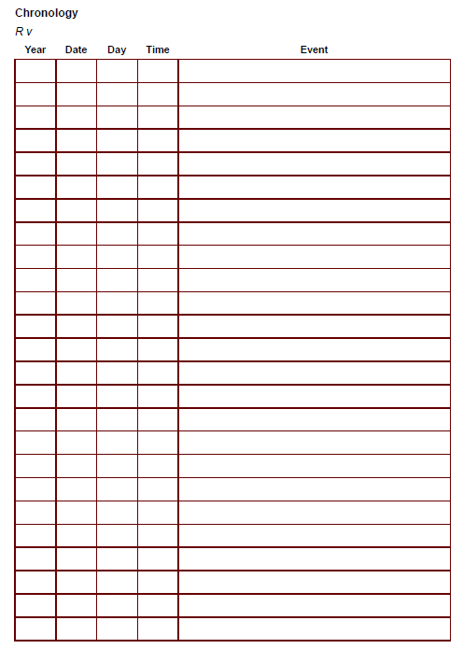

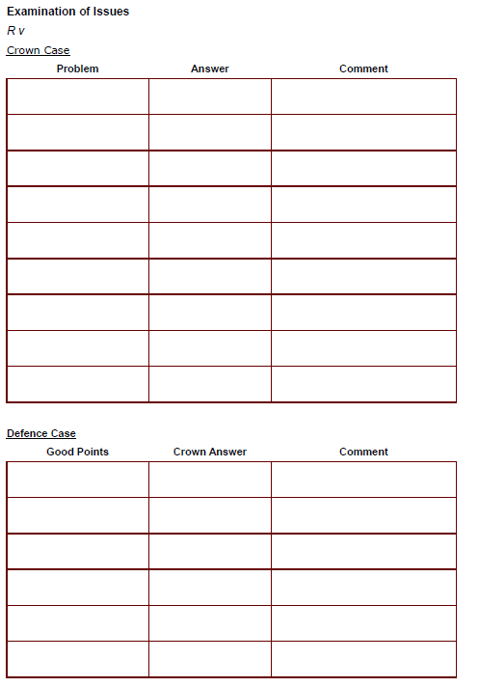

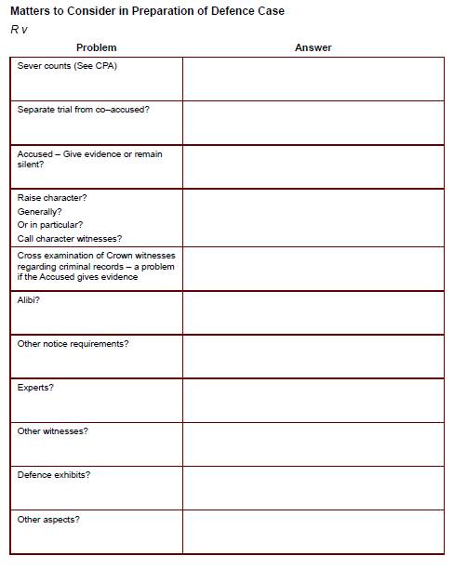

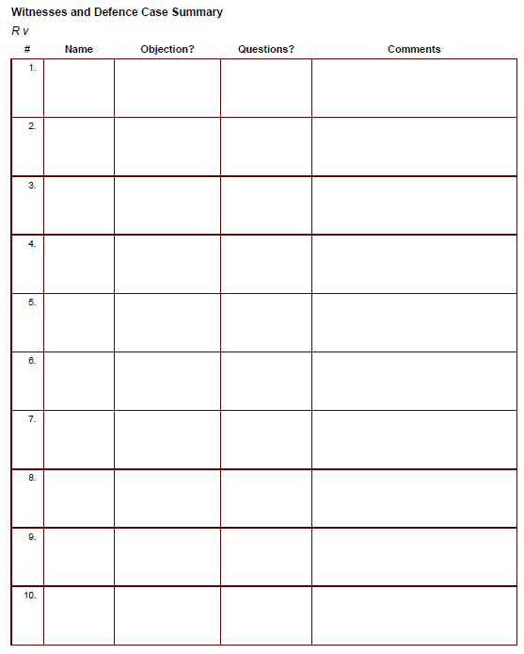

Appendix B
